SCHOOL NAME: __________________________ EXAMINATION NO: ______________

SOUTH EAST EDUCATION DIVISION
2025 MALAWI SCHOOL CERTIFICATE OF EDUCATION MOCK EXAMINATION

MATHEMATICS

Subject Number: M038/I
Thursday, 27th March Time Allowed: 2 hours
8:00 – 10:00 am

PAPER I

THEORY
(100 marks)

Instructions
- This paper contains 10 printed pages. Please check.
Question number | Tick if answered | Do not write in these columns

- Answer all the 20 questions in this paper
- The maximum number of marks for each answer is indicated against each question.
- Scientific calculators may be used.
- All working must be clearly shown.
- Write your Examination Number and School Name at the top of each page.
7. In the table provided on this page, tick against the question number you have answered.
8. Hand in your filled questions paper to the invigilator when time is called to stop writing

© 2025 SEED MOCK Turn over/…

Answer all the questions.
- Factorise completely 2- 11xy + 5y ( 4 marks )

- Without using a calculator, simplify 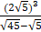 (5 marks)

3. Make h subject of the formula in 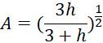 (3 marks)

4. Given that matrix A = 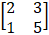 B = 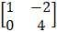 and C = 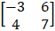, evaluate B(A + C). (4marks).

Continued/…
- If 8, X, Y and 27 are four consecutive terms of GP. Find the values of X and Y. (5 marks)

- Given that (– 1)(x + C) is identical to + 7 + 11x – 4. Find the values of B and C.
(5 marks)

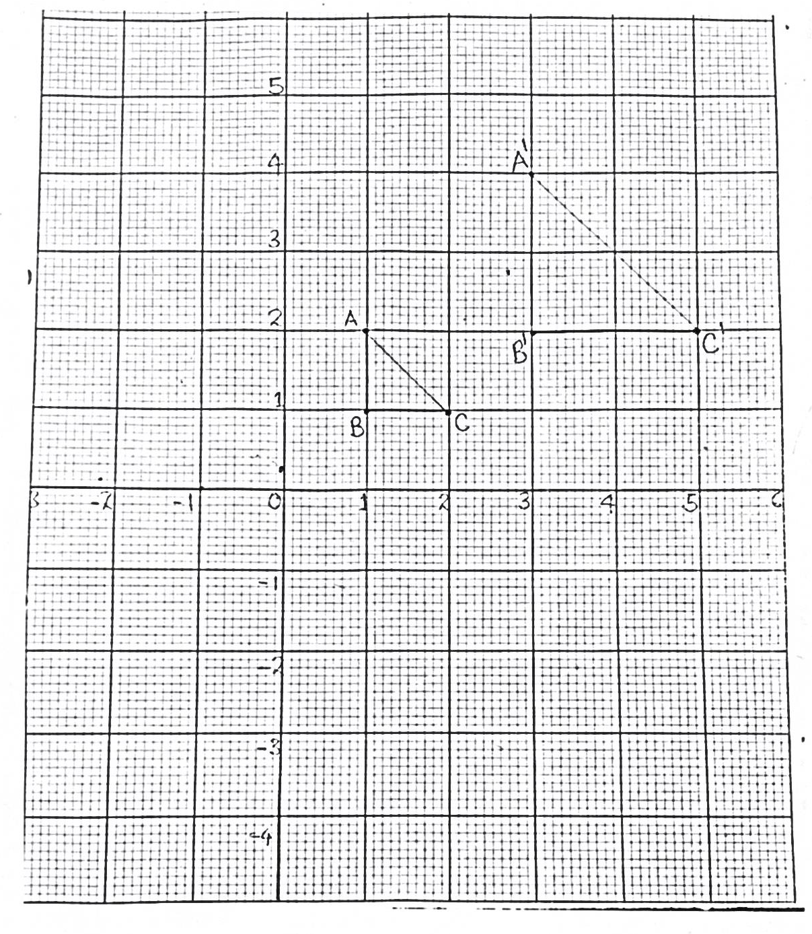
- Figure 1 shows a triangle ABC and its enlargements A^{I},B^{I},C^{I}. Copy and complete the figure to show in the same diagram the coordinates for the centre of enlargement. (4marks)

Continued/…
- Given that points P= (1, 3.1); Q= (3, 9.3) and R= (5, y) are collinear, find the value of y.
(5marks)

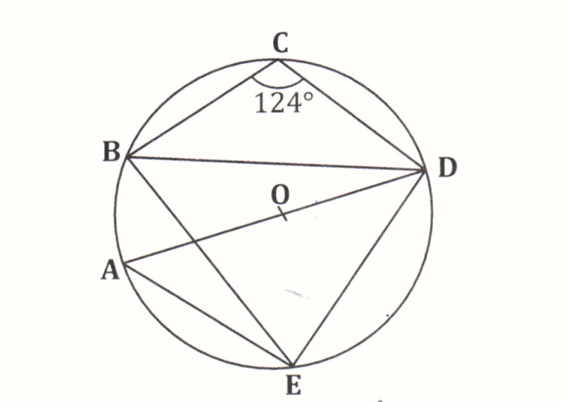
- Figure 2 shows a circle ABCDE centre o in which angle BCD =.

Figure 2
Calculate the value of angle ADB. (4marks)

Continued/…
- From the top of a tower, the angle of depression of a car is . Given that the tower is 15m high, calculate the distance of the car from the foot of the tower, giving the answer in simplest surd form. (5marks)

- Two similar jugs have capacities of 2 litres and ¼ litre. If the height of a larger jug is 30cm, find the height of the smaller jug. Give your answer correct to 2 decimal places. (6marks)

Continued/…
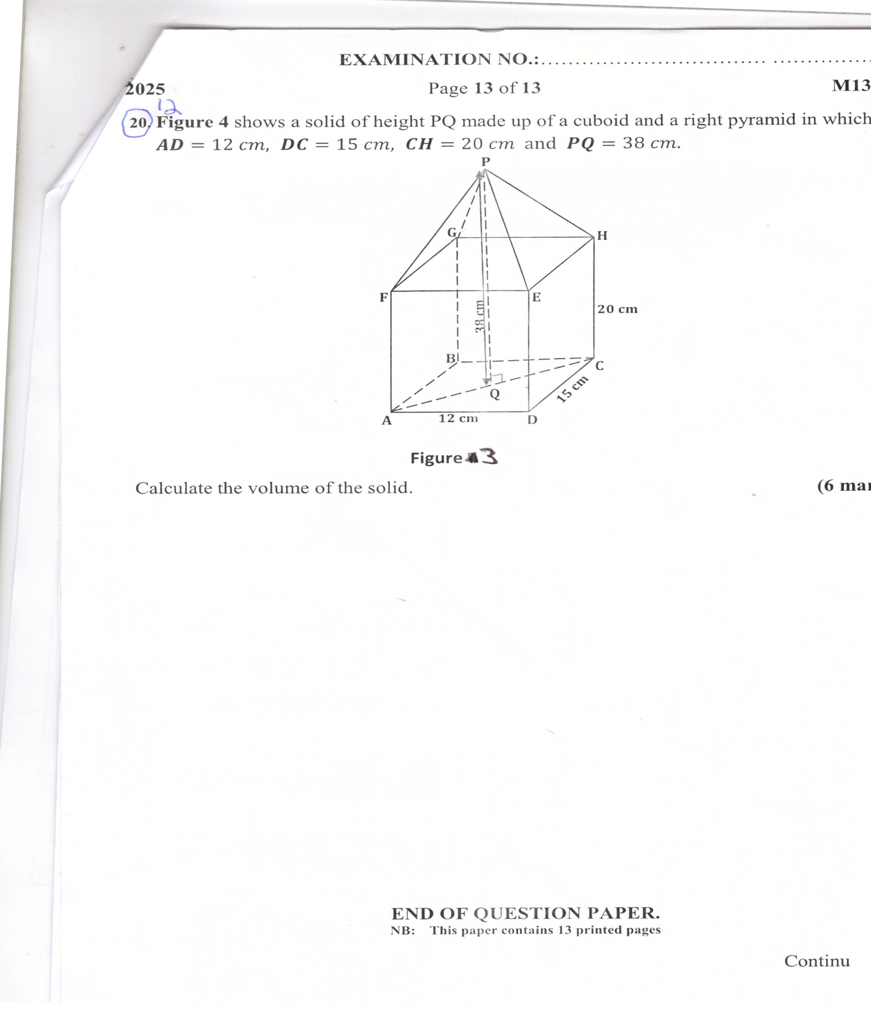
- Figure 3 shows a solid of height QP made up of a cuboid and a right pyramid in which AD = 12cm, DC = 15cm, CH = 20cm and QP = 38cm.

Figure 3
Calculate the volume of the solid. (6marks)

- The function f(x) = ax – b, where a and b are constants. Given that f (2) = - 13 and f (- 3 ) = 2, find the values of a and b. (5marks)

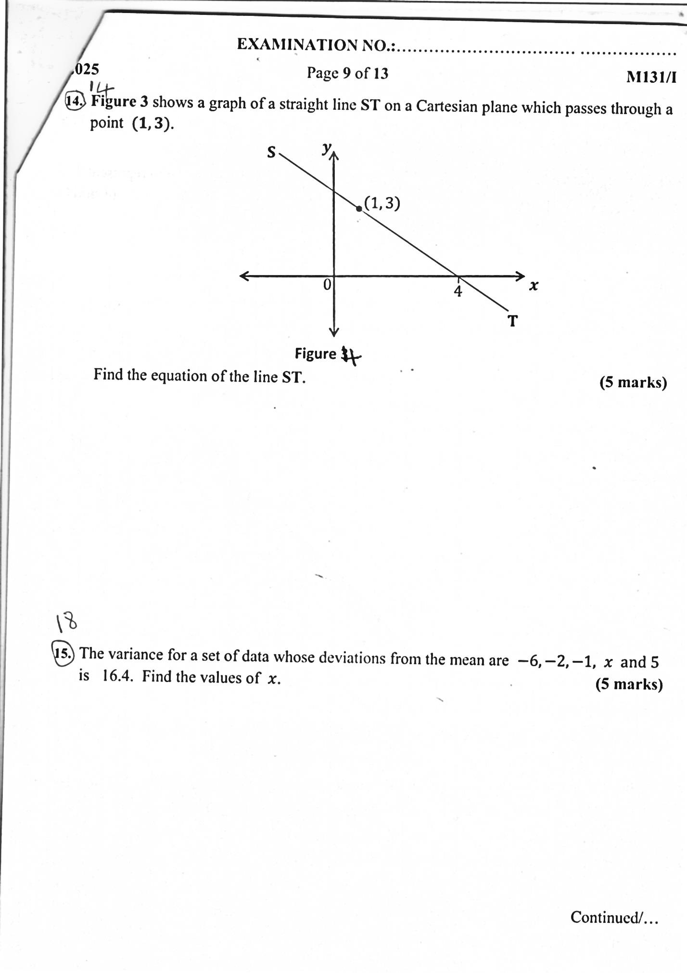
- Figure 4 shows a graph of a straight line ST on a Cartesian plane which passes through a point (1, 3). (5marks)

Figure 4
Find the equation of the line ST.

- A quantity P varies directly as the square root of m and inversely as the cube of r.
Given that m = 16 and r = 2, P = 5. Find P when m = 225 and r = 5. (5marks)

Continued/…
- On the same axes, sketch the graphs to show the region bounded by the following inequalities by shading the unwanted region.
X ≤ 3
Y – 2x ≤ 4
Y ˃ 1 – x
Y ˂ 5
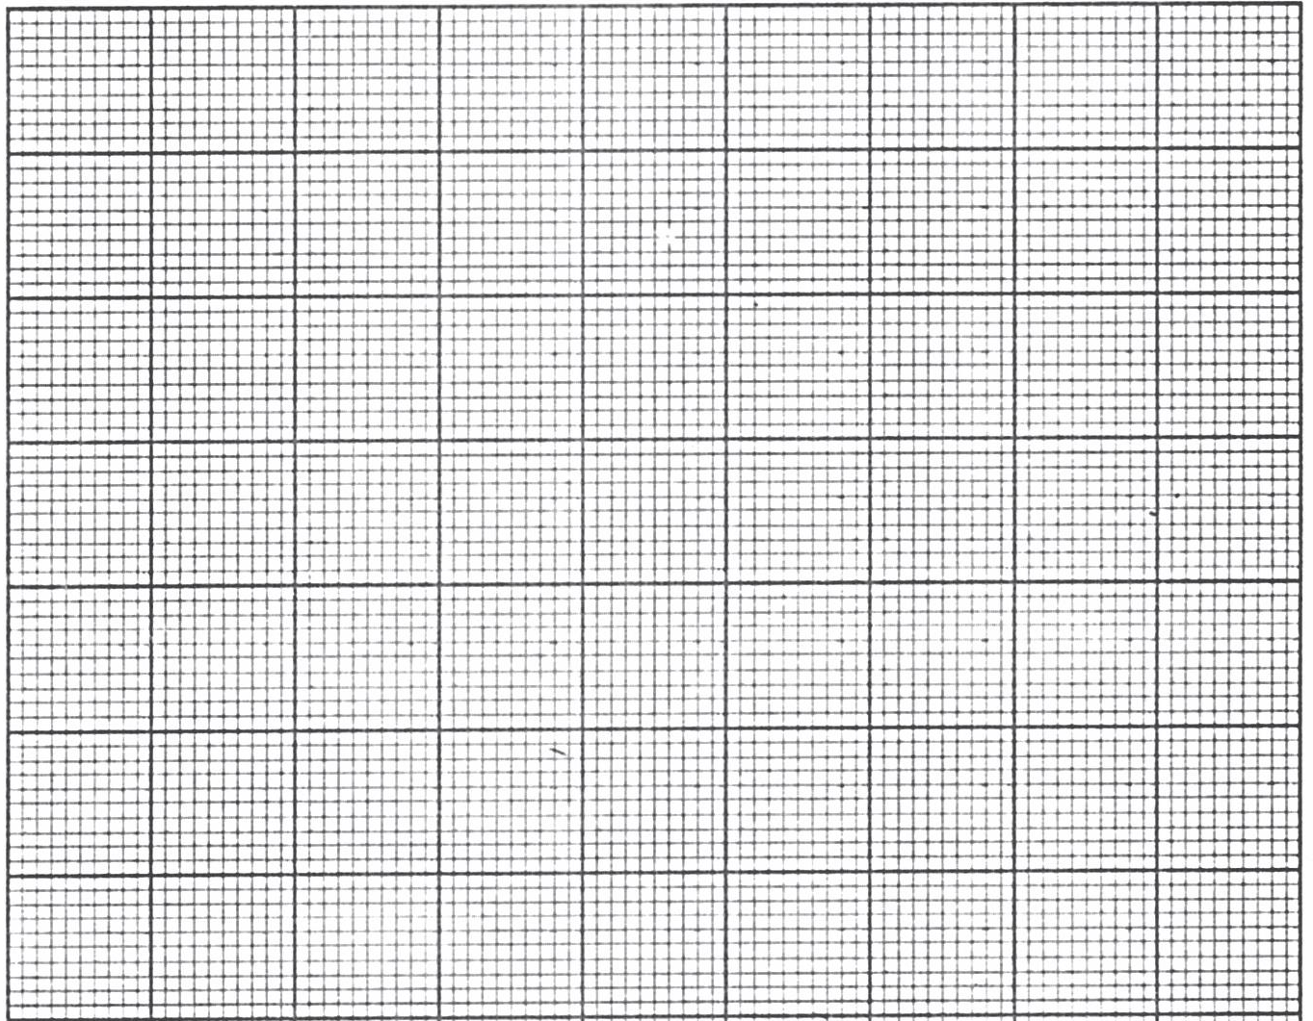
(6 marks)
- Figure 5 shows a circle WXYZ with centre O, angle ZWX = a and angle ZYX = 4a.
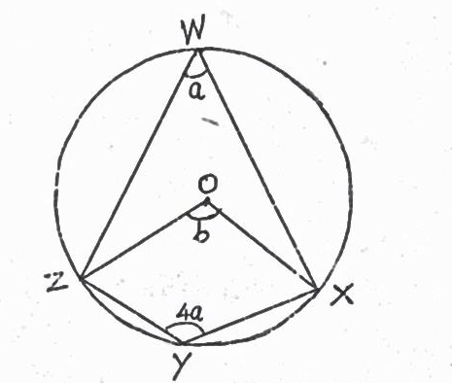

Figure 5
Calculate the value of b. (5marks)
Continued/…

- The variance for a set of data whose deviations from the mean are – 6, - 2, - 1, x and 5 is 16.4. Find the values of x. (5marks)

- Solve the equation 2 - 4 = 0, leaving your answer to 2 decimal places. (5marks)

Continued/…
- A moving train accelerated from 15m/s to 25m/s in 5 seconds. It then changed to 10m/s in the next 3 seconds. It travelled at this speed for 4 seconds before it came to a stop in the next 3 seconds.
- Using a scale of 2 cm to represent 5 units on the vertical axis and 2 cm to represent
2 units on the horizontal axis, draw a speed – time graph for the train. (4marks)
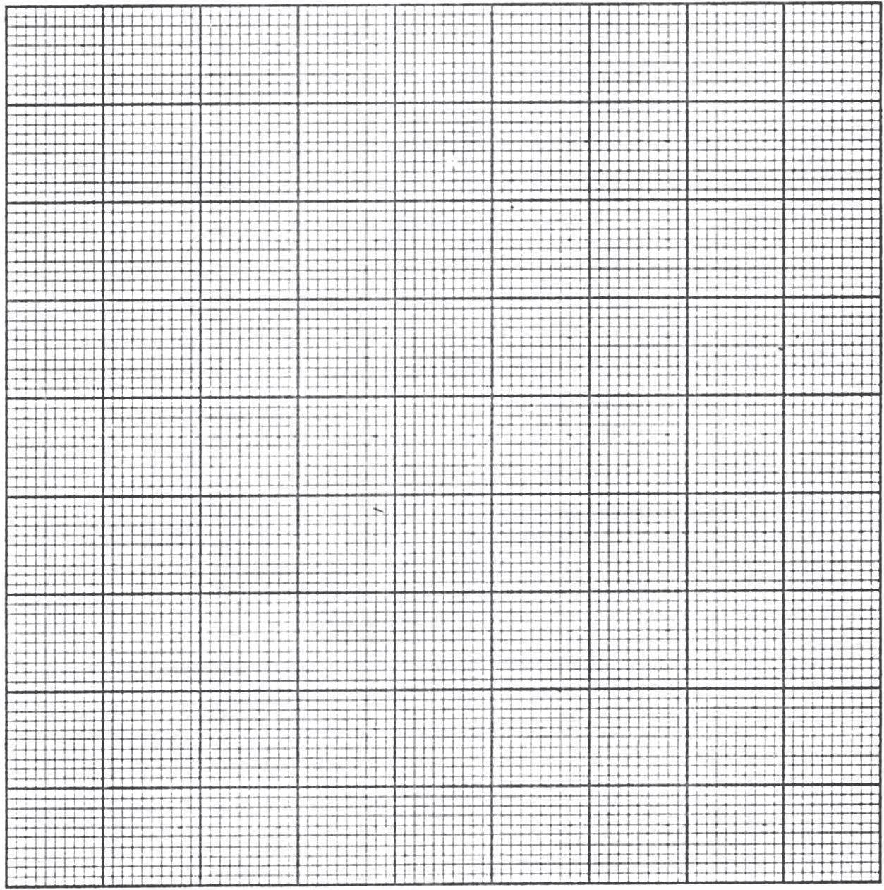

(b) Use the graph to calculate the deceleration in the last 3 seconds. (2marks)

END OF QUESTION PAPER
NB: This paper contains 10 printed pages

